BEFORE:-

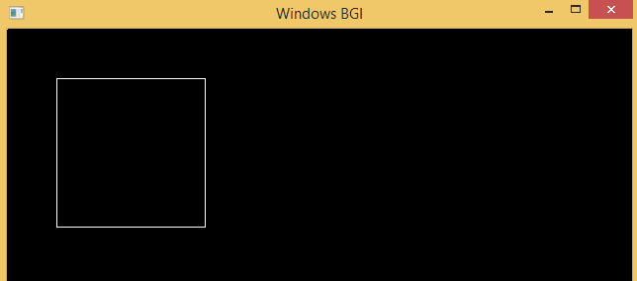

AFTER:-

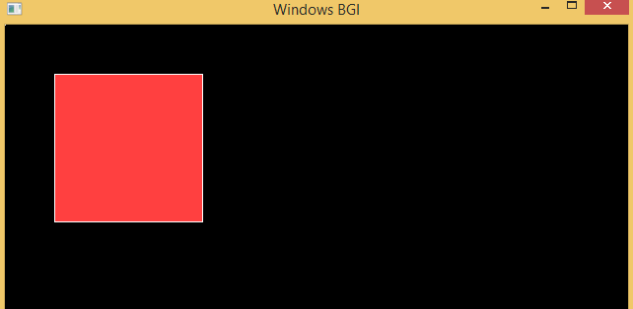

rectangle(xmin,ymax,xmax,ymin);

cout<<"\tCLIPPED POLYGON"; getch(); closegraph(); return 0 ; }

BEFORE:-

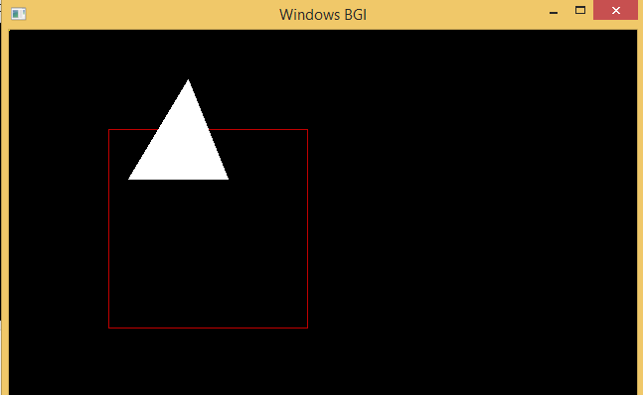

AFTER:-

